# Hirestar- Recruitment Dashboard

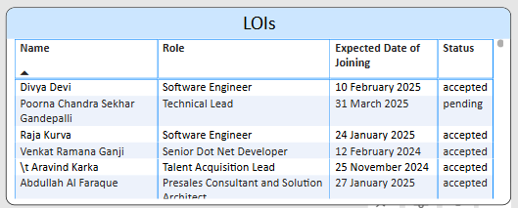

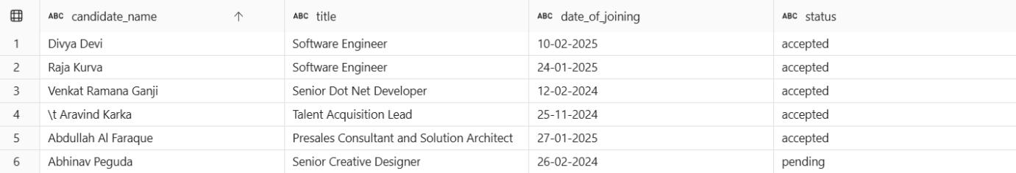

SELECT

    candidate_name, title, date_of_joining,

    CASE WHEN status = 'accepted' THEN status WHEN status = 'new' THEN 'pending' ELSE status END AS status

FROM [RecruitmentLakehouse].[dbo].[hirestar_lois];

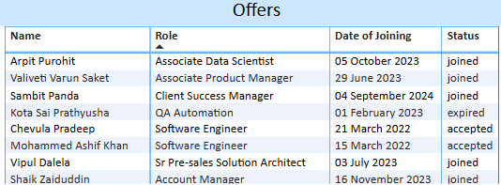

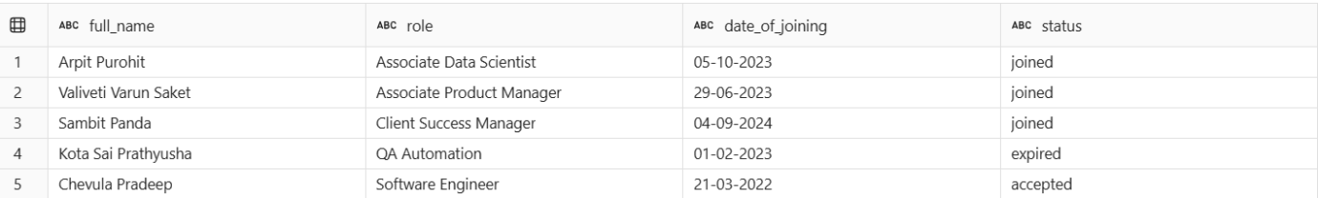

select full_name,role,date_of_joining,status from [RecruitmentLakehouse].[dbo].[hirestar_offers]

order by role

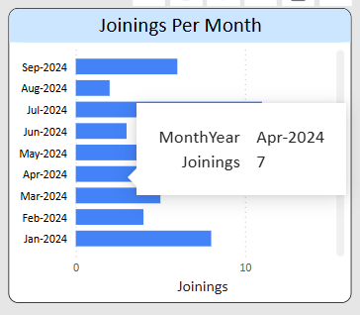

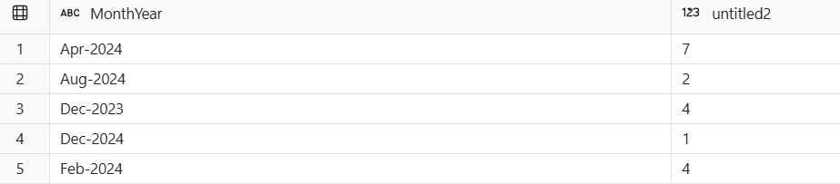

select MonthYear, count(distinct email_id) from [RecruitmentLakehouse].[dbo].[hirestar_offers]

where status = 'joined' and role not in ('Associate Software Engineer')

group by MonthYear

order by MonthYear

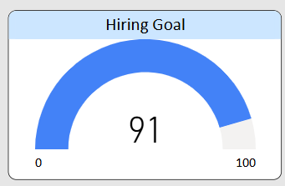

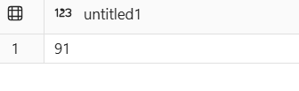

select count(distinct email_id) from [RecruitmentLakehouse].[dbo].[hirestar_offers]

where status='joined' and role not in ('Associate Software Engineer')

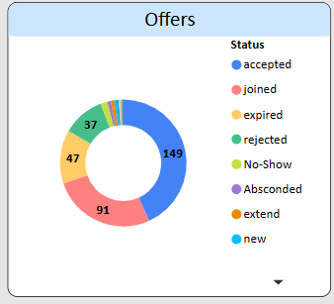

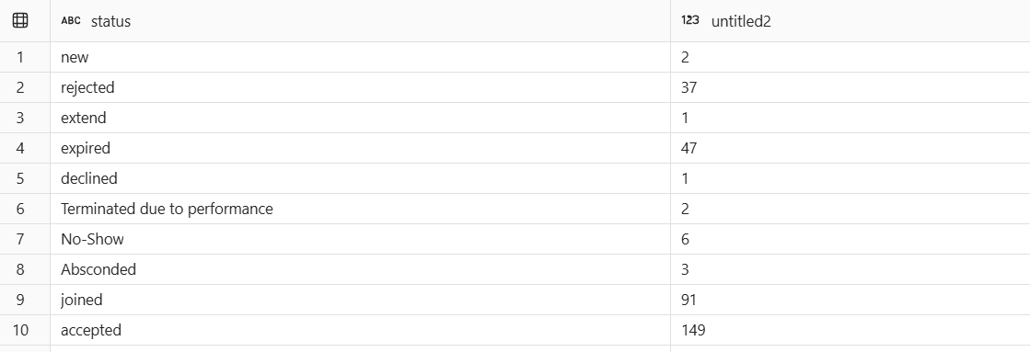

select status, count(distinct email_id) from [RecruitmentLakehouse].[dbo].[hirestar_offers]

where role != 'Associate Software Engineer'

group by status

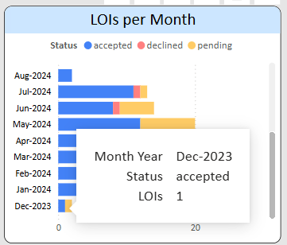

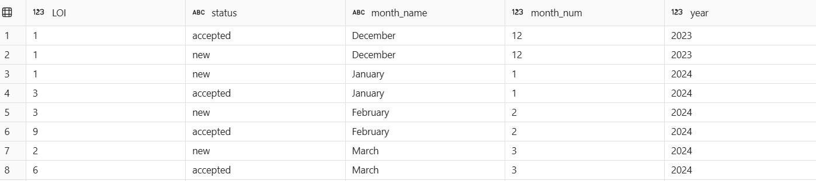

SELECT

   COUNT(email_id) AS LOI,

   status,

   FORMAT(TRY_CONVERT(DATETIME, createdAt, 103), 'MMMM') AS month_name,

   MONTH(TRY_CONVERT(DATETIME, createdAt, 103)) AS month_num,

   YEAR(TRY_CONVERT(DATETIME, createdAt, 103)) AS year

FROM

   hirestar_lois

WHERE

   TRY_CONVERT(DATETIME, createdAt, 103) IS NOT NULL

GROUP BY

   status,

   FORMAT(TRY_CONVERT(DATETIME, createdAt, 103), 'MMMM'),

   MONTH(TRY_CONVERT(DATETIME, createdAt, 103)),

   YEAR(TRY_CONVERT(DATETIME, createdAt, 103))

ORDER BY

   year,

   month_num;

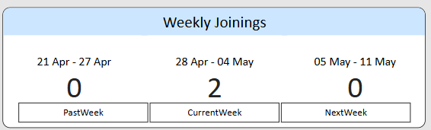

(Backend working on it)

WITH OfferDataWithWeek AS (

    SELECT

        email_id,

        TRY_CAST(date_of_joining AS DATE) AS date_of_joining,

        status,

        CASE

            WHEN TRY_CAST(date_of_joining AS DATE) BETWEEN '2025-04-21' AND '2025-04-27' THEN 'PastWeek'

            WHEN TRY_CAST(date_of_joining AS DATE) BETWEEN '2025-04-28' AND '2025-05-04' THEN 'CurrentWeek'

            WHEN TRY_CAST(date_of_joining AS DATE) BETWEEN '2025-05-05' AND '2025-05-11' THEN 'NextWeek'

            ELSE NULL

        END AS WeekPCN

    FROM hirestar_offers

    WHERE TRY_CAST(date_of_joining AS DATE) IS NOT NULL

)

--select DISTINCT status from OfferDataWithWeek;

--select * from OfferDataWithWeek where WeekPCN is not null

SELECT

    COUNT(DISTINCT CASE

        WHEN WeekPCN = 'PastWeek' AND status IN ('joined', 'accepted') THEN email_id

        END) AS LastWeekJoinings,

    COUNT(DISTINCT CASE

        WHEN WeekPCN = 'CurrentWeek' AND status IN ('joined', 'accepted') THEN email_id

        END) AS CurrentWeekJoinings,

    COUNT(DISTINCT CASE

        WHEN WeekPCN = 'NextWeek' AND status IN ('accepted', 'new') THEN email_id

        END) AS NextWeekJoinings

FROM OfferDataWithWeek;